Name: _____________________________ Mark: /48

**Year 7 Physics**

**End of Topic Test**

**Multiple Choice**

Please place a cross the correct answer on table below

|  |  |  |  |  |
| --- | --- | --- | --- | --- |
|  |  |  |  |  |
| |  |  | | --- | --- | | **Number** | **Answer** | | **1** | **A B C D** | | **2** | **A B C D** | | **3** | **A B C D** | | **4** | **A B C D** | | **5** | **A B C D** | | **6** | **A B C D** | | **7** | **A B C D** | | **8** | **A B C D** | | **9** | **A B C D** | | **10** | **A B C D** | | **11** | **A B C D** | | **12** | **A B C D** | | **13** | **A B C D** | | **14** | **A B C D** | | **15** | **A B C D** | | **16** | **A B C D** | | **17** | **A B C D** | |  |  |  |  |
|  |  |  |  |  |
|  |  |  |  |  |
|  |  |  |  |  |

|  |  |  |  |  |
| --- | --- | --- | --- | --- |
|  |  |  |  |  |

1 Force is measured in:

A Kilograms

B Newtons

C Litres

D Kelvin

2 A machine that lifts a 60 N load with an effort of 20 N has a mechanical advantage of:

A 120

B 1200

C 2

D 3

3 When using a machine called a force multiplier you apply:

A a small force over a large distance.

B a large force over a large distance.

C a small force over a small distance.

D a large force over a small distance.

4 The pivot point of a lever is called the:

A Load.

B speed multiplier.

C distance multiplier.

D Fulcrum.

5 When a ramp is used by removalists to lift a piano into a moving van, compared to lifting the piano vertically up (straight up from the ground):

A the force needed is reduced but the distance over which it acts is increased.

B the distance is increased, but the force required is the same.

C the force needed is reduced and this acts over a shorter distance.

D the force required is increased but the distance over which it acts is reduced.

6 A screw driver is an example of a:

A lever.

B mass multiplier.

C pulley.

D Wheel and axle.

7 These tweezers are an example of

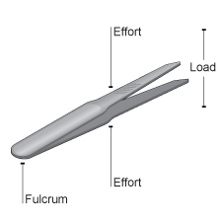

A first-class levers.

B a ramp.

C third-class levers.

D wedges.

8 An axe head is an example of a simple machine called a:

A screw.

B lever.

C wheel.

D wedge.

9 The machine in this picture is called a:

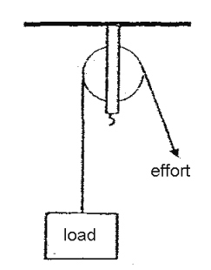

A single fixed pulley

B single movable pulley

C bus

D Wheel and axle

10 Jakeb is using a metre ruler as a lever. The fulcrum of the lever is positioned at the end of the ruler that is attached to the stand and clamp as shown in the diagram. Jakeb investigates how the effort force required to support the load changes as the position of the load shifts along the lever.

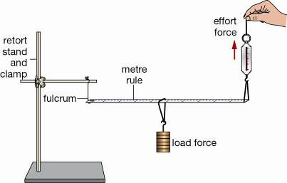

Jakeb’s results table is shown below.

|  |  |
| --- | --- |
| **Distance of load from fulcrum (cm)** | **Effort (N)** |
| 10 | 40 |
| 20 | 80 |
| 30 | 120 |
| 40 | 160 |
| 50 | 200 |

If the load was positioned 60 cm from the fulcrum, the effort Jakeb would need to supply is

A 200 N

B 160 N

C 240 N

D 300 N

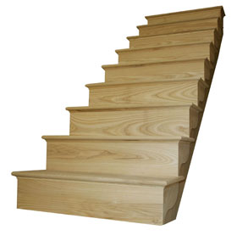11 What sort of simple machine is the picture showing?

A screw.

B wedge.

C lever.

D ramp.

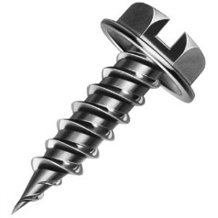12 What sort of simple machine is the picture showing?

A screw.

B wedge.

C lever.

D ramp.

[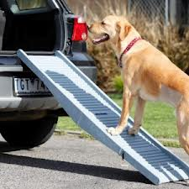](http://www.google.com.au/imgres?um=1&hl=en&tbo=d&biw=1920&bih=931&tbm=isch&tbnid=6WvDnYyh9OxTuM:&imgrefurl=http://www.dogsinmotion.com.au/shop/petstep-folding-dog-ramp/&docid=gpfhVy7WNrp6rM&imgurl=http://www.dogsinmotion.com.au/wp-content/uploads/2012/10/folding-ramp-300x300.jpg&w=300&h=300&ei=JOeuUL-pGuWZiQfCrIDgAg&zoom=1&iact=hc&vpx=947&vpy=485&dur=123&hovh=225&hovw=225&tx=112&ty=110&sig=105643095784672155594&page=1&tbnh=141&tbnw=131&start=0&ndsp=49&ved=1t:429,r:34,s:0,i:253)13 What sort of simple machine is the picture showing?

A screw.

B wedge.

C lever.

D ramp.

14 What sort of simple machine is the picture showing?

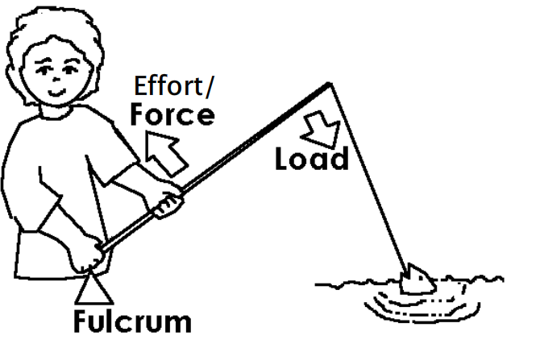

A screw.

B wedge.

C lever.

D ramp.

15 Which statement below is false?

A Machines reduce the load that has to be moved.

B Machines transfer energy.

C Simple machines can be combined to make complex machines.

D A ramp is a type of inclined plane.

16 Which of the following is a definition for a screw?

A An incline plane wrapped around a cylinder.

B A Lever wrapped around a cylinder.

C A wheel and axle.

D A pulley with the rope removed.

17 Which of the following is a good definition for a pulley?

A A Lever wrapped around a cylinder. The cylinder is grooved

B A wheel with an immovable cylinder attached to its centre. The wheel is grooved.

C A wheel the spins on an axle. The wheel is grooved and a rope runs in the groove.

D A grooved wheel that cannot spin on an axle as the axle immovable. The wheel is grooved.

1. **Onto the diagrams below label the fulcrum, load and effort. Then state the class of lever.**

|  |  |
| --- | --- |
| Picture | Class of lever? |
|  |  |
| http://www.clker.com/cliparts/W/I/i/0/I/1/scissors-md.png |  |
| http://www.lyvemedia.com/delta/grade/website_files/images/levers/levers_inv1_02.gif |  |
| http://www.mstworkbooks.co.za/technology/gr8/Tech_English_LB_Grade8-term3_1-web-resources/image/Tech2_gr8_ch1_fig4_opt.jpeg |  |
|  |  |

(10 marks)

**2. Circle TRUE or FALSE for the following statements.** (4 marks)

a) A lever is a simple machine that can increase the effort TRUE FALSE

supplied to get a job done.

b) If using a crowbar to lift a tree stump, then the tree stump TRUE FALSE

is called the effort.

c) A crowbar used as a lever rotates about a point called TRUE FALSE

the fulcrum.

d) When using the claw of a hammer to pull a nail out of a TRUE FALSE

piece of wood, the hammer gives a force advantage.

**3. You can measure how much easier a task has become by calculating the mechanical advantage a machine produces.**

Remember that the equation is

Work out the problems below, showing **all** working out.

**a) Jake applies an effort of 200 N to lift a bag of weight 600 N using a long piece of wood as a lever.**

**Calculate the mechanical advantage of the lever.** (2 marks)

**b) Paige lifts a box that weighs 150 N by using an effort of 25 N using a metal rod as a lever.**

**Calculate the mechanical advantage of the lever.** (2 marks)

**4) Harry and Shania have a lever positioned underneath a heavy rock that they are trying to shift. They are trying to work out where to place a smaller rock to use as a fulcrum in order to lift the heavy rock with the least amount of effort.**

Harry thinks they should put the fulcrum as close to the heavy rock as possible. Shania thinks they should put the fulcrum as far away as possible from the heavy rock.

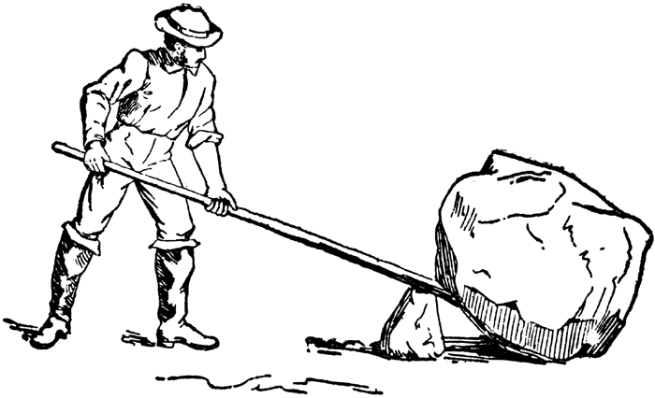**Explain** who is correct and **why**. (2 marks)

_______________________________________________________________

_______________________________________________________________

_______________________________________________________________

__________________________________________________________________________________________

__________________________________________________________________________________________

**5) You can measure the mechanical advantage provided by a ramp.**

Remember that the equation is



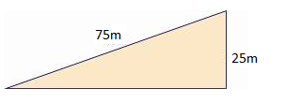Work out the mechanical advantage of the slope below, showing **all** working out. (2 marks)

**6**) Raymond was buying a new crowbar. He wanted to know which would make it easiest to remove nails from wood.

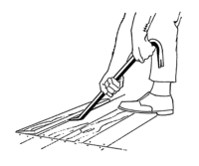 He found the Mechanical advantage of 4 different brands of crowbar. The results are in the table below.

Changing Mechanical Advantage of Different Brands of Crow bar

|  |  |
| --- | --- |
| Brand | Mechanical Advantage |
| V | 5 |
| W | 6 |
| X | 4 |
| Z | 7 |

1. Graph this data onto the graph below. (5 marks)



1. Which crow bar would be the best at removing nails?

________________________________________________________________________________

(1 mark)

7) Mandy was lifting a heavy box with a pulley. She noticed that the pulley was squeaking. She oiled the axle of the pulley. The squeaking stopped and the box became easier to lift. Explain why these changes occurred after oiling the pulley axle?

(3 marks)

____________________________________________________________________________________________________________________________________________________________________________________________________________________________________________________________________________________________________________________________________________________________________________________________________________________________________________________________________________________________________________

THIS WORD SLEUTH IS **NOT** GOING TO BE MARKED!!!!

